Malaysia: Recent Economic Developments and Outlook

# GDP growth in 2019 rose

GDP growth rose by 4.3% year-on-year (yoy) in 2019. On the demand side, private consumption (59.8% of GDP) contributed the most to growth, with 4.4 percentage points (pp). On the supply side, services (54.2% of GDP) contributed the most to growth, with 3.3pp.

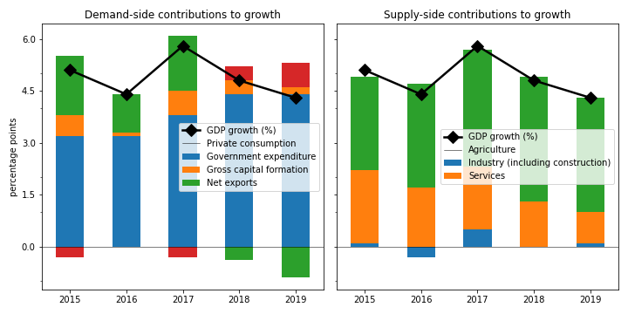

## Net exports jumped the fastest on the demand side

Net exports jumped by the largest margin (12.8%). Private consumption picked up by 7.6%. Government expenditure grew by 2.0%. On the other hand, gross capital formation contracted by 3.9%.

## On the supply side, services grew the fastest

Services grew the most rapidly (6.1%). Industry (including construction) increased by 2.3%. Agriculture picked up by 2.0%.

## Unemployment stayed; inflation declined

Unemployment stayed from 3.3% in 2018 to 3.3% in 2019, while inflation declined from 0.9% to 0.7%. At the end of 2020, the central bank set the policy rate at 1.8%.

## Current account balance deficit

The current account balance (CAB) recorded a deficit at nan% of GDP in 2019, compared to 2.1% in 2018.

China is the top export destination (14.2% of exports in 2019). Other major exports partners include Singapore (13.9%), USA (9.7%), and China, Hong Kong SAR (6.7%). Top export products are electrical machinery and equipment and parts thereof; sound recorders and reproducers; television image and sound recorders and reproducers, parts and accessories of such articles (34.4% of exports).

Top imports origins are China (20.7%), Singapore (10.5%), USA (8.1%), and Japan (7.5%). Major import commodities are electrical machinery and equipment and parts thereof; sound recorders and reproducers; television image and sound recorders and reproducers, parts and accessories of such articles(27.3% of imports).

# Output contracted in Q3 2020

Output plunged by 2.7% yoy in Q3 2020 (-17.0% in the previous quarter). Exports slowed down by the largest margin at -4.7% yoy.

## Leading indicators

Consumer confidence index was in the pessimistic territory at 91.6 in Q3 (85.9 in Q2). Industrial production shrank by 2.3% yoy in November (1.1% yoy in October).

## Inflation picked up

Inflation rose to 2.0% yoy in January (-1.5% yoy in December). Meanwhile, the central bank maintained the policy rate to 1.8% in January.

# Outlook favorable this year

As of January 2021, Consensus Economics panelists project economic growth ending at 6.7% in 2021, while in 2022, the panelists foresee growth at 5.3%. Over the same period, consumption is expected to change by 7.4% and 5.9%, while investment is projected to change by 9.8% and 6.1%. Industrial production is seen to change by 5.8% and 4.3%. Finally, Consensus Economics foresee inflation at 1.8% in 2021 and 2.0% in 2022.

*Sources: Consensus Economics, The World Bank, UN Comtrade, Haver Analytics, and National Sources. Accessed 05 February 2021.*